Project Data
Customer Company |  | Offer Number
Project Name |  | Offer Date
Unit Project Code

Product Specifications

RTER090
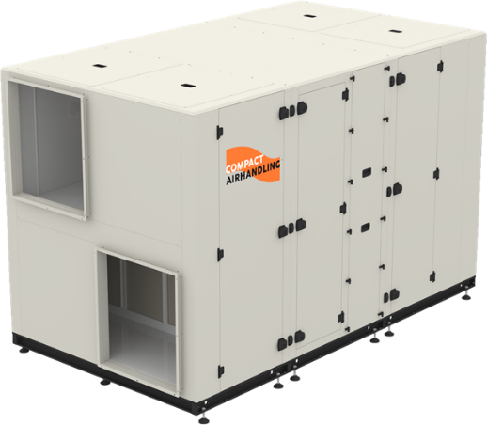 | FOUR RTER-Rotor Type Heat Recovery Unit is used in restaurants, stores, historical buildings, offices where fresh air is needed. Designed to take charge of the air of fresh air. It works with indoor air conditioning devices. The exhaust air absorbed from the interior environment is transferred to the external  environment after the heat transfer with the fresh air thanks to the hygroscopic energy recovery rotor. With the automatic control system, it works 7 days 24 hours without any intervention in the most appropriate way.  High efficiency rotor type heat exchanger Thermal efficiency up to 90%  Moisture transfer efficiency up to 65% Optional CO2 or pressure sensor  High efficiency EC Plug fans  50 mm thick double-walled panel construction  RTER Modal:Top and side switcable duct connection RTER-A Modal: Side duct connection

Product Model | RTER090
Product Type | Commercial Type Heat Recovery
Heat Recovery Type | Aluminum Rotary
Unit Casing | Double wall - Inside: 0.8 mm galvanized sheet
Unit isolation | 50 mm 70 kg/m3-Rockwool
Casing Air Leakage | 0
Unit Frame | -
Service Direction | Both Sides
Voltage / Frequency / Phase (V / Hz / Ph) | 380/50/3
Operating conditions | -20 ~ 46 ° C Temperature, 90% Max.RH Outdoor Air
Standard Air Density (kg/m³) | 1.2

Dimensions
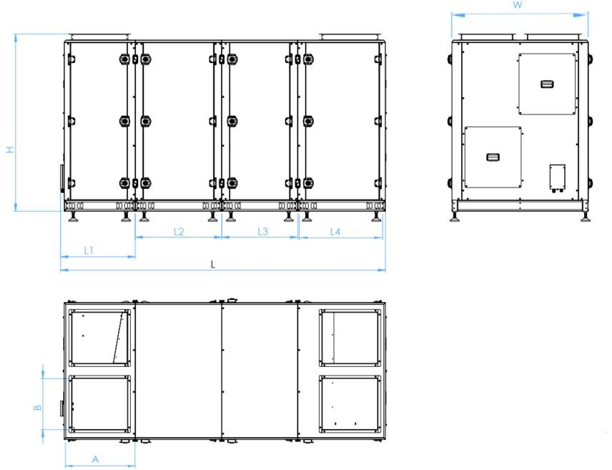

L | W | H | A | B | L1 | L2 | L3 | L4 | W(kg)
3128 | 1350 | 1716 | 600 | 530 | 740 | 780 | 685 | 890 | 976

Performance Data

Supply Air Flow | m³/h | 7500 | Heat Recovery Efficiency | % | 77.11
External Static Pressure | Pa | 250 | Heat Recovery Capacity | kW | 38.98
Return Air Flow | m³/h | 7500 | Additional Heating Capacity | kW | 0
External Static Pressure | Pa | 250 | Additional Cooling Capacity | kW
Unit Total Power / Current | kW/A | 4.64/7.44 | Air Outlet Temperature | °C | 20.42
Supply Side Internal Pressure Loss | Pa | 0 | Exhaust Side Internal Pressure Loss | Pa | 0
SFPint,total | W/m³/s | 1350.94 | Energy Efficiency Class | -

Heat Recovery Data

Heat Recovery Type | Aluminum Rotary - Enthalpy Rotor
Fin Pitch (mm) | 1.6

Winter |  | Outside Air | Return Air
Air Inlet Flow | m³/h | 7500 | 7500
Air Inlet Temperature (DB / WB) | °C | 5 / 3 | 25 / 14.04
Air Inlet Relative Humidity | % | 72 | 28
Air Outlet Temperature (DB / WB) | °C | 20.42 / 10.84 | 9.60 / 7.06
Air Outlet Relative Humidity | % | 28.11 | 70.36
Heat Recovery Pressure Drop | Pa | 225.47 | 254.17
Heat Recovery Efficiency (Dry / Wet) | % | 77.11 / 17.87 | -
Heat Recovery Capacity (Sensible / Latent) | kW | 38.98 / 1.80 | -38.96 / -1.80
Heat Recovery Capacity (Total) | kW | 40.77 | -40.76
Condensation | kg/h | 0.00 | 0.00

Summer |  | Outside Air | Return Air
Air Inlet Flow | m³/h | 7500 | 7500
Air Inlet Temperature (DB / WB) | °C | 33 / 22.38 | 22 / 13.89
Air Inlet Relative Humidity | % | 40 | 40
Air Outlet Temperature (DB / WB) | °C | 24.57 / 19.08 | 30.47 / 17.85
Air Outlet Relative Humidity | % | 59.94 | 28.01
Heat Recovery Pressure Drop | Pa | 265.72 | 249.88
Heat Recovery Efficiency (Dry / Wet) | % | 76.6502 / 17.12 | -
Heat Recovery Capacity (Sensible / Latent) | kW | 21.57 / 6.39 | 21.59 / 6.39
Heat Recovery Capacity (Total) | kW | 27.95 | 27.98
Condensation | kg/h | 0.00 | 0.00

Filter Data

 |  | SA Filter 1 | SA Filter 2 | EA Filter | EA Filtre 2
Filter Class | - |  | F7 | M5
Filter Class (ISO 16890) | - |  | ISO ePM1 50% | ISO ePM10 50%
Filter Initial Pressure Drop | Pa |  | 176.54 | 156.54
Filter Final Pressure Drop | Pa |  | 200 | 170
Filter Average Pressure Drop | Pa |  | 188.27 | 163.27
Filter Surface Air Velocity | m/s |  | 5.4111 | 5.4111 | 5.4111

Fan Data

 |  | Outside Air | Return Air
Air Flow | m³/h | 7500 | 7500
Fan Speed | d/d | 1918.4 | 1907.44
Nominal Fan Speed | d/d | 2040 | 2040
Fan Power | Watt | 2251.41 | 2294.51
Operating Point Current | A | 3.68 | 3.76
Voltage / Frequency / Phase | V/Hz/Ph | 380 / 50 / 3 | 380 / 50 / 3

Fan LWA |  |  | LWA (In+Out) | LWA | 63Hz | 125Hz | 250Hz | 500Hz | 1kHz | 2kHz | 4kHz | 8kHz
Supply Fan | Inlet | dBA | 88,22 | 80,96 | 68,60 | 70,10 | 79,80 | 78,10 | 74,40 | 72,00 | 72,30 | 71,50
 | Outlet | dBA |  | 87,29 | 71,50 | 71,70 | 79,70 | 83,90 | 83,60 | 79,10 | 76,30 | 73,20
Return Fan | Inlet | dBA | 88,13 | 80,96 | 68,60 | 70,10 | 79,80 | 78,10 | 74,40 | 72,00 | 72,30 | 71,50
 | Outlet | dBA |  | 87,29 | 71,50 | 71,70 | 79,70 | 83,90 | 83,60 | 79,10 | 76,30 | 73,20

Fan LPA | @ 1 m |  | LPA (In+Out) | LPA | 63Hz | 125Hz | 250Hz | 500Hz | 1kHz | 2kHz | 4kHz | 8kHz
Supply Fan | Inlet | dBA | 80.24 | 72.98 | 60.62 | 62.12 | 71.82 | 70.12 | 66.42 | 64.02 | 64.32 | 63.52
 | Outlet | dBA |  | 79.31 | 63.52 | 63.72 | 71.72 | 75.92 | 75.62 | 71.12 | 68.32 | 65.22
Return Fan | Inlet | dBA | 80.24 | 72.98 | 60.62 | 62.12 | 71.82 | 70.12 | 66.42 | 64.02 | 64.32 | 63.52
 | Outlet | dBA |  | 79.31 | 63.52 | 63.72 | 71.72 | 75.92 | 75.62 | 71.12 | 68.32 | 65.22

